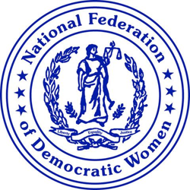

Action Alert April 13, 2020
From NFDW President Cindy Jenks
The National Federation of Democratic Women salutes the numerous nurses, doctors, first responders, and other health care professionals who are risking their own lives each day of the COVID-19 pandemic. We also honor the many essential workers that have kept our food, pharmaceuticals, and other much needed supplies available for us while they too are risking their lives supporting all citizens during this national emergency.
Too many nurses, doctors and other healthcare workers are facing working without all the protective masks, gowns, and other critical items they need to protect themselves. They have had to work long grueling hours, and deal with horrendous situations and death. These heroes also work in the midst of the fear that they have the virus and are asymptomatic. Therefore, they can transmit this deadly disease to their patients and then take it home to their own families. Nevertheless, they return to the front lines again and again, with no end in sight.
The daily stress that is cast upon these individuals who are working to take care of our country is horrific. Many on the frontline have referred to their experiences as being “in a war.” This mental anguish can take a tremendous toil, and can even leave these individuals with post traumatic syndrome.
NFDW is asking our membership to contact your Congressional representatives and senators and ask them to honor these hometown heroes with a special recognition that can express the gratitude of all Americans for their selfless dedication while they care for their fellow citizens.

