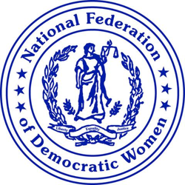

Action Alert May 18, 2020

From NFDW President Cindy Jenks:
“NFDW Members must call their Senators and ask them support the Heroes Act that will provide another round of stimulus to those in dire straits and need help,” said President Jenks.
The U.S. House of Representatives has passed the Heroes Act, a $3 Trillion stimulus. Funding will go to states and local governments, virus testing, another round of $1,200 checks to individuals, the U.S. Post Office, student loan payments, and more. The bill passed 208 – 199 with 11 Democrats in swing districts voting against the bill and one Republican voting for it.
The Republican Senate leadership has said that the bill will not be taken up because the “bill will be dead on arrival.” President Trump has said that he will veto the bill if it comes to him. Republicans have said that we should “take a pause” in the funding.
Speaker Nancy Pelosi has responded… “the virus isn’t taking a pause. Paying the rent isn’t taking a pause.”
36 million jobs have been lost because of the pandemic conditions. Millions are filing for unemployment funding and the unemployment rate has now reached 14.7%. States and local governments are strained and even with cutting back on spending, some are tittering on bankruptcy. Under the Heroes Act, state and local governments will receive $875 Billion in funds.
Republican Peter King, who voted for the bill, said, “Now we’re talking about survival. This is no time for politics.”
“Hopefully, all NFDW members will call their Senators and urge others to call too. We can demonstrate that Democrats care about our fellow citizens,” said President Jenks.

